Hypothesis Testing Exercise

1. A F&B manager wants to determine whether there is any significant difference in the diameter of the cutlet between two units. A randomly selected sample of cutlets was collected from both units and measured? Analyze the data and draw inferences at 5% significance level. Please state the assumptions and tests that you carried out to check validity of the assumptions.

**Ans.**

Significance level = 5%

Null Hypothesis [H0] = µ1 = µ2

Alternate Hypothesis [H1] = µ1 ≠ µ2

Alpha = 0.05/2

0.025

Condition = If the P value is < alpha reject the null hypothesis

If the P value is > alpha accept the null hypothesis

By python code **T Test P value is 0.47223**

p_value=stats.ttest_ind(UnitA,UnitB)

Ttest_indResult(statistic=0.7228688704678063, pvalue=0.4722394724599501)

The P value is greater than the alpha.

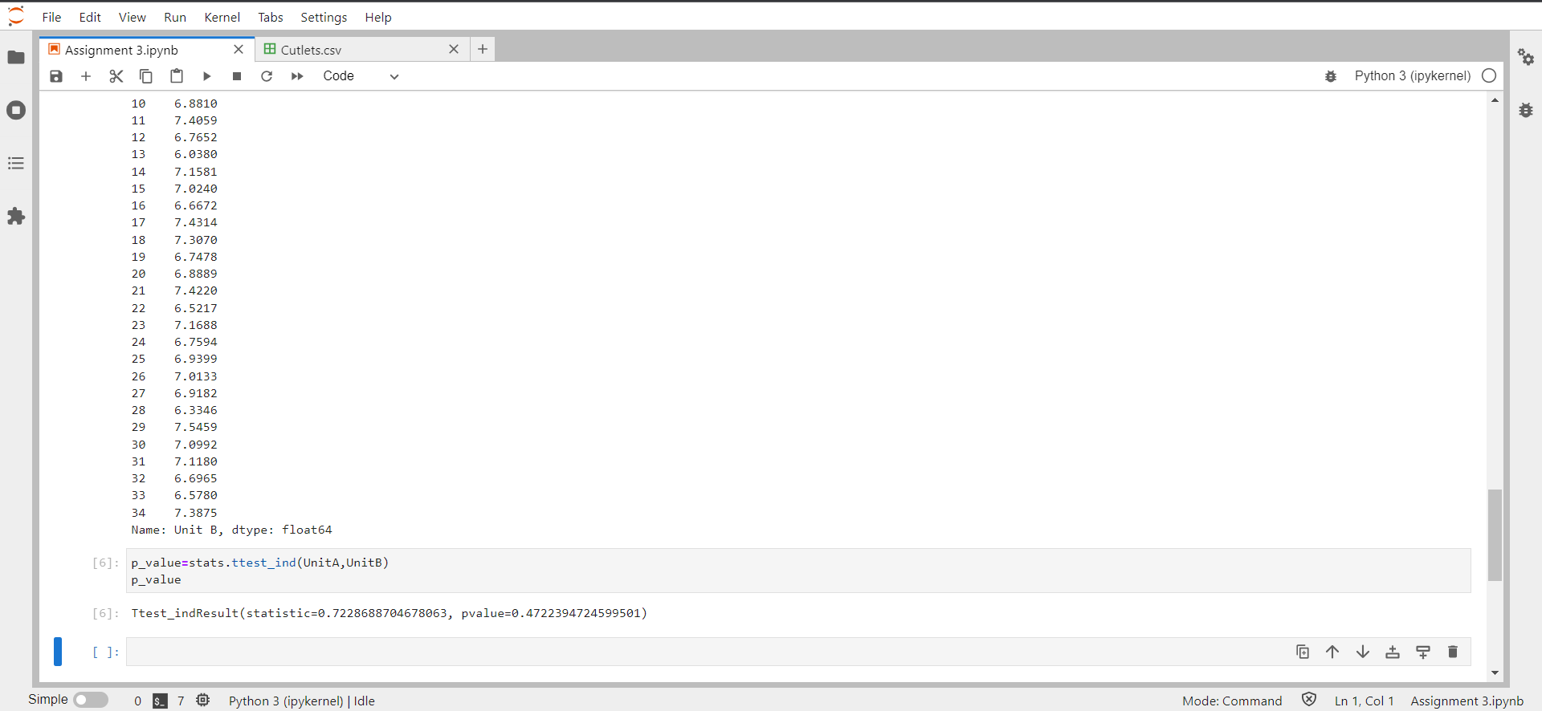 **Therefore, we accept the null hypothesis so the both units are same and there is no difference between them.**

1. A hospital wants to determine whether there is any difference in the average Turn Around Time (TAT) of reports of the laboratories on their preferred list. They collected a random sample and recorded TAT for reports of 4 laboratories. TAT is defined as sample collected to report dispatch.

Analyze the data and determine whether there is any difference in average TAT among the different laboratories at 5% significance level.

**Ans.**

Significance level = 5%

Null hypothesis [H0] = L1 = L2 = L3 = L4

Comparing the mean between all the sample data of labs

By python code **P_value is 2.11567**

p_value = stats.f_oneway(y.iloc[:,0],y.iloc[:,1],y.iloc[:,2],y.iloc[:,3])

F_onewayResult(statistic=118.70421654401437, pvalue=2.1156708949992414e-57)

**The P_value is almost equal to 0.**

**So, we’ll reject the Null Hypothesis.**

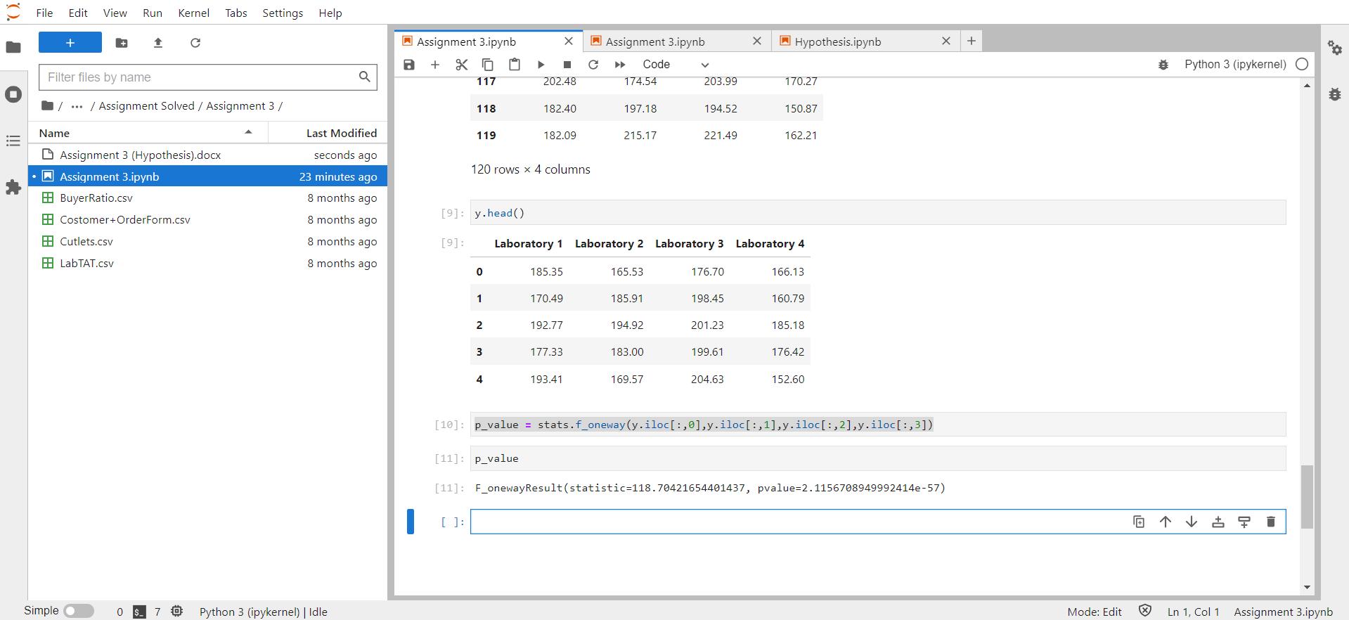

1. Sales of products in four different regions is tabulated for males and females. Find if male-female buyer rations are similar across regions.

|  |  |  |  |  |
| --- | --- | --- | --- | --- |
|  | **East** | **West** | **North** | **South** |
| Males | 50 | 142 | 131 | 70 |
| Females | 550 | 351 | 480 | 350 |

**Ans.**

Null Hypothesis [H0] = Independent of male and female region

Alternate Hypothesis [H1] = Dependent of male and female region

Statistics = 1.595945538661058

P_value = 0.6603094907091882

Alpha_value = 0.05

Therefore, we fail to reject null hypothesis means male and female region are Independent.

They are similar across the region.

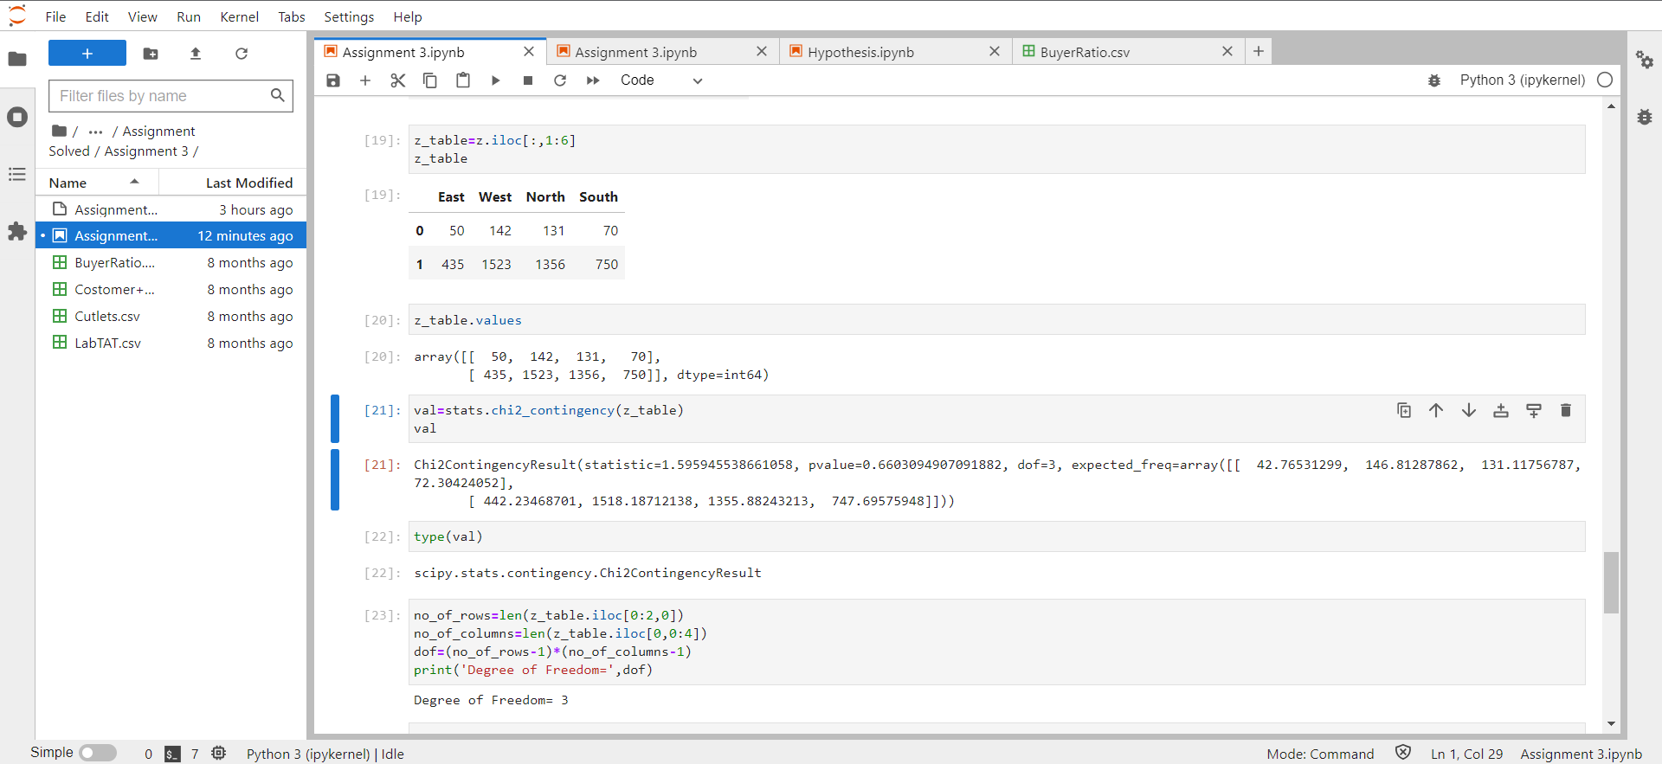

1. TeleCall uses 4 centers around the globe to process customer order forms. They audit a certain % of the customer order forms. Any error in order form renders it defective and has to be reworked before processing. The manager wants to check whether the defective % varies by centre. Please analyze the data at *5%* significance level and help the manager draw appropriate inferences.

**Ans.**

Here, input is 4 discrete variables

So, H0 = % of varies are equal for each country

H1 = % of varies are not equal to anyone of the country

As per the python, the **chi2 stat value is 3.858960685820355 & degree of freedom is 3**

**P_value is 0.2771020991233135** which is more than the alpha value

then we will accept the null hypothesis.

